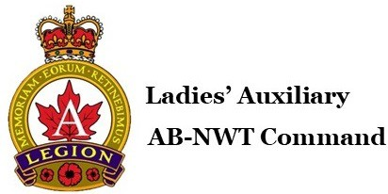

**LADIES’ AUXILIARY ALBERTA-NWT** - Membership Application

Ladies’ Auxiliary Branch: Branch No. Branch Mailing Address: **Members Information:**

Applicant's Name:

Last First Init.

Address:

Street Address City Province Postal Code

Phone Number (H) (C)

Date of Birth: E-mail:

Name of Serving Member: Relationship to Serving Member:

**Category of Membership:** Ordinary Associate Voting Affiliate

**I HEREBY AGREE** to abide by the Constitution, Rules and By-Laws of the Ladies' Auxiliary to the Royal Canadian Legion:

Applicant Signature : Date: Proposed by: Seconded by: Date: Date of Initiation:

L.A. Secretary: L.A. President:

Type of volunteer activities that interest you:

Volunteering  Participating in Educational Activities  Fund Raising  Helping with Auxiliary Projects  Working with Young People 

**Distribution List:** one copy to Branch, one copy to the member, and one copy to Ladies’ Auxiliary Command Office 5003 52 Ave, Wetaskiwin AB T9A 0W9 | Phone: 780-368-5015 | Fax: 780-368-2045| [lacommand152@gmail.com](mailto:lacommand152@gmail.com)